Nicholas Pun 27872167

Q3.

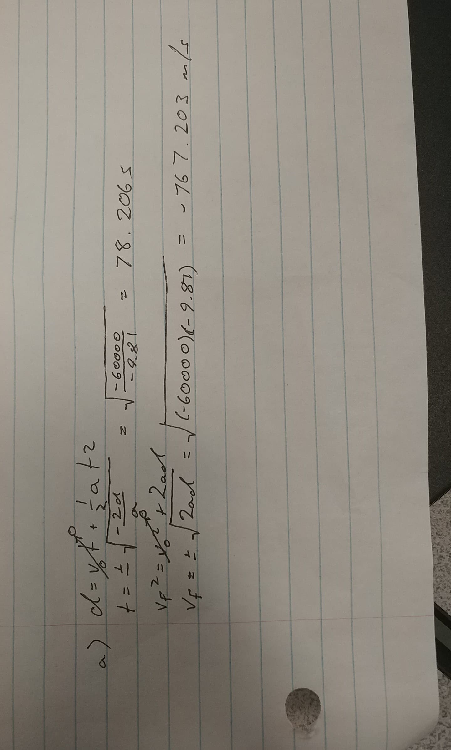

b) Fall time: 78.000000s

Final velocity error: 0.263648%

dt = 3s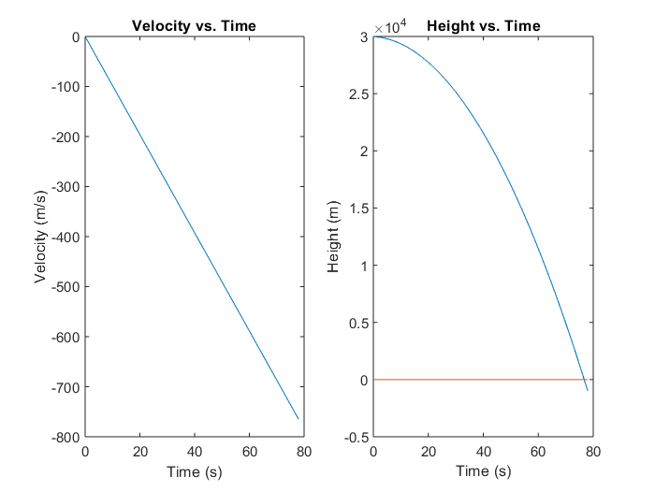

c) Fall time: 680.000000s

dt = 1s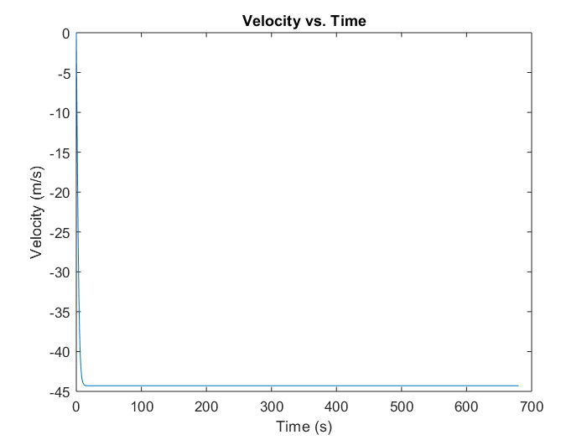

d) Fall time: 315.000000s

dt = 1s 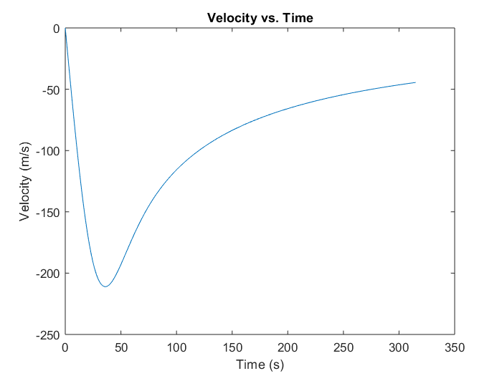

the acceleration becomes positive at one point because the atmospheric density becomes thick enough to cause the acceleration due to drag to be larger in magnitude than acceleration due to gravity.

e) plots above

the acceleration becomes positive at one point because the atmospheric density becomes thick enough to cause the acceleration due to drag to be larger in magnitude than acceleration due to gravity.

code (copy and paste everything into a matlab .m file and run):

clear; clc;

% Constants

m = 100;

disp = -30000;

g = -9.81;

v0 = 0;

b = 0.5;

% Euler step

f = @(t,m,b) m*t + b;

% Implement Euler step

v = zeros(1,1);

stopper = 0;

y = zeros(1,1);

i = 1;

dt = 3;

while stopper > disp

v(i+1) = f(dt,g,v(i));

y(i) = stopper - disp;

i = i+1;

stopper = f(dt,v(i),stopper);

end

y(i) = stopper - disp;

% Plot

figure(1);

t = 0:dt:dt*(length(v)-1);

subplot(1,2,1);

plot(t,v);

title('Velocity vs. Time');

xlabel('Time (s)');

ylabel('Velocity (m/s)');

subplot(1,2,2);

plot(t,y); hold on;

plot(t,zeros(1,length(t)));

title('Height vs. Time');

xlabel('Time (s)');

ylabel('Height (m)');

fprintf('Fall time: %fs\n', t(length(t)));

v_true = -sqrt(2*g*disp);

fprintf('Final velocity error: %f%%\n', (1-v(length(v))/v_true)*100);

% Part c

v1 = zeros(1,1);

a1 = g;

stopper1 = 0;

dt1 = 1;

i1 = 1;

while stopper1 > disp

a1 = g - b*v1(i1)*abs(v1(i1))/m;

v1(i1+1) = f(dt1,a1,v1(i1));

i1 = i1+1;

stopper1 = f(dt1,v1(i1),stopper1);

end

figure(2)

t1 = 0:dt1:dt1*(length(v1)-1);

plot(t1,v1);

title('Velocity vs. Time');

xlabel('Time (s)');

ylabel('Velocity (m/s)');

fprintf('Fall time: %fs\n', t1(length(t1)));

% Part d

v2 = zeros(1,1);

g2 = g*(1+(-disp/6370000))^(-2);

a2 = g2;

b2 = 0.5*exp(disp/8000);

stopper2 = 0;

dt2 = 1;

i2 = 1;

while stopper2 > disp

a2 = g2 - b2*v2(i2)*abs(v2(i2))/m;

v2(i2+1) = f(dt2,a2,v2(i2));

i2 = i2+1;

stopper2 = f(dt2,v2(i2),stopper2);

g2 = g*(1+((-disp+stopper2)/6370000))^(-2);

b2 = 0.5*exp((disp-stopper2)/8000);

end

figure(3)

t2 = 0:dt2:dt2*(length(v2)-1);

plot(t2,v2);

title('Velocity vs. Time');

xlabel('Time (s)');

ylabel('Velocity (m/s)');

fprintf('Fall time: %fs\n', t2(length(t2)));